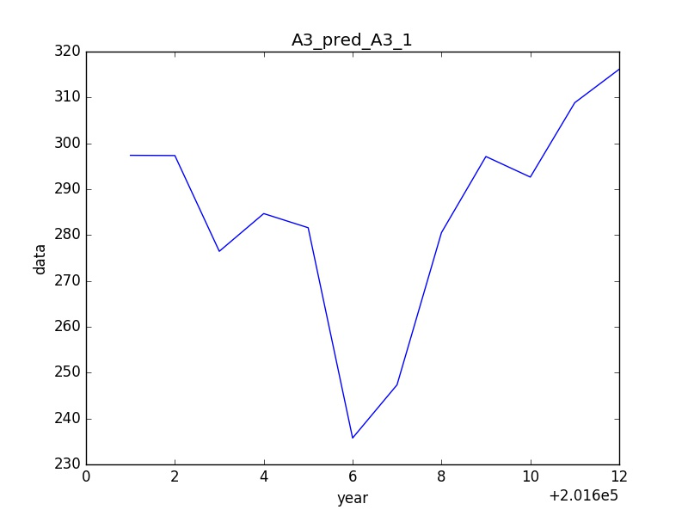

201601: 297.387040044

201602: 297.338653353

201603: 276.461195778

201604: 284.684699341

201605: 281.602107366

201606: 235.751433269

201607: 247.345597846

201608: 280.53506885

201609: 297.125471326

201610: 292.642911031

201611: 308.863895464

201612: 316.15087526

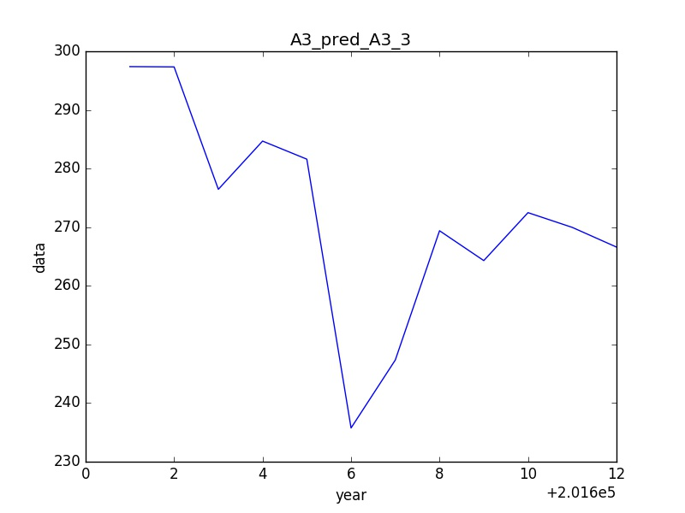

201601: 297.387040044

201602: 297.338653353

201603: 276.461195778

201604: 284.684699341

201605: 281.602107366

201606: 235.751433269

201607: 247.345597846

201608: 269.393195526

201609: 264.302287138

201610: 272.479871801

201611: 269.965260612

201612: 266.607943266

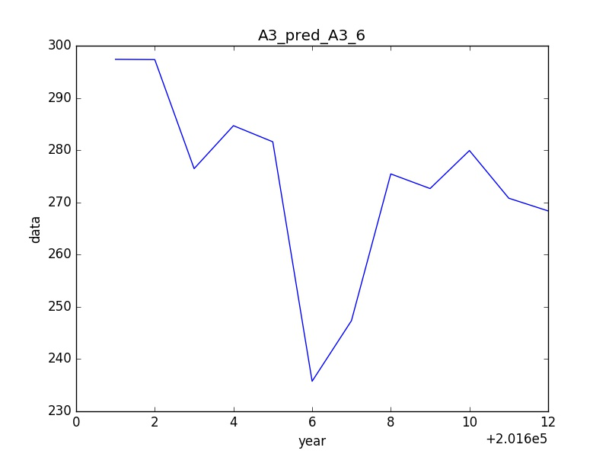

201601: 297.387040044

201602: 297.338653353

201603: 276.461195778

201604: 284.684699341

201605: 281.602107366

201606: 235.751433269

201607: 247.345597846

201608: 275.449072422

201609: 272.650008726

201610: 279.92707904

201611: 270.799504783

201612: 268.369284393

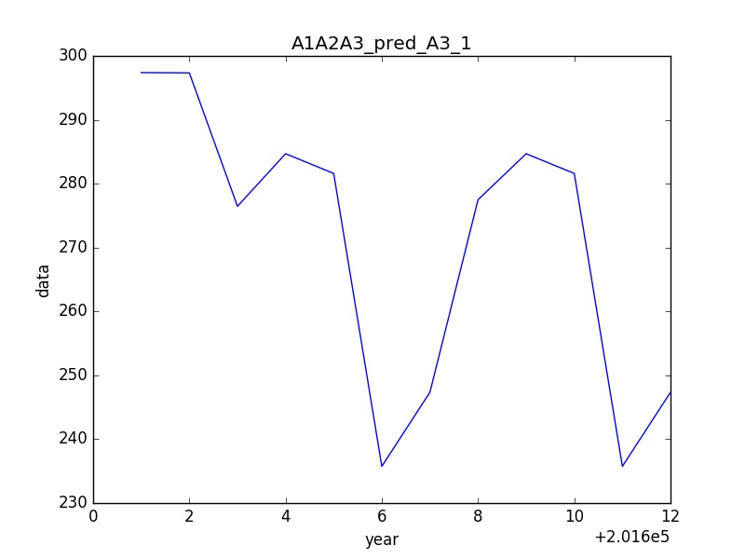

201601: 297.387040044

201602: 297.338653353

201603: 276.461195778

201604: 284.684699341

201605: 281.602107366

201606: 235.751433269

201607: 247.345597846

201608: 277.48972133

201609: 284.685148876

201610: 281.601807024

201611: 235.751885471

201612: 247.34602362

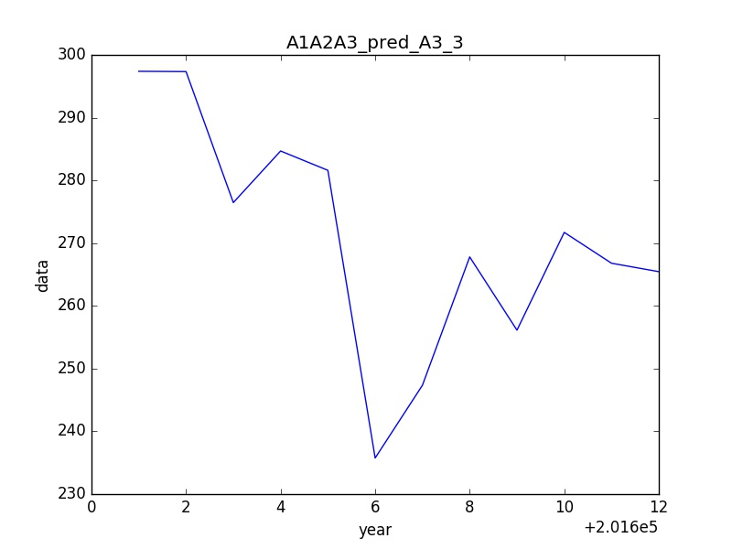

201601: 297.387040044

201602: 297.338653353

201603: 276.461195778

201604: 284.684699341

201605: 281.602107366

201606: 235.751433269

201607: 247.345597846

201608: 267.801301442

201609: 256.127200642

201610: 271.713913046

201611: 266.797021296

201612: 265.451812347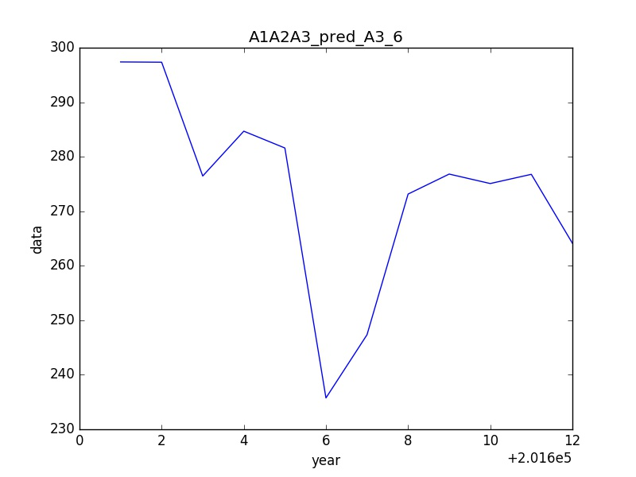

201601: 297.387040044

201602: 297.338653353

201603: 276.461195778

201604: 284.684699341

201605: 281.602107366

201606: 235.751433269

201607: 247.345597846

201608: 273.153089947

201609: 276.818492614

201610: 275.082860642

201611: 276.773495436

201612: 264.134595769

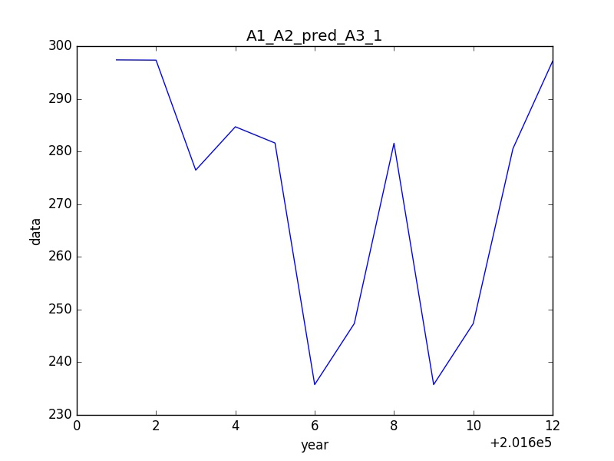

201601: 297.387040044

201602: 297.338653353

201603: 276.461195778

201604: 284.684699341

201605: 281.602107366

201606: 235.751433269

201607: 247.345597846

201608: 281.556714931

201609: 235.751885471

201610: 247.34602362

201611: 280.53506885

201612: 297.125471326

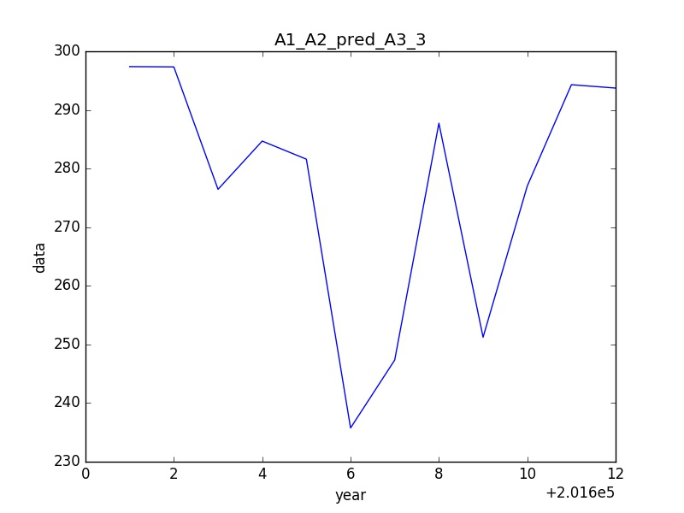

201601: 297.387040044

201602: 297.338653353

201603: 276.461195778

201604: 284.684699341

201605: 281.602107366

201606: 235.751433269

201607: 247.345597846

201608: 287.731773226

201609: 251.231697984

201610: 277.006086069

201611: 294.303377835

201612: 293.729818112

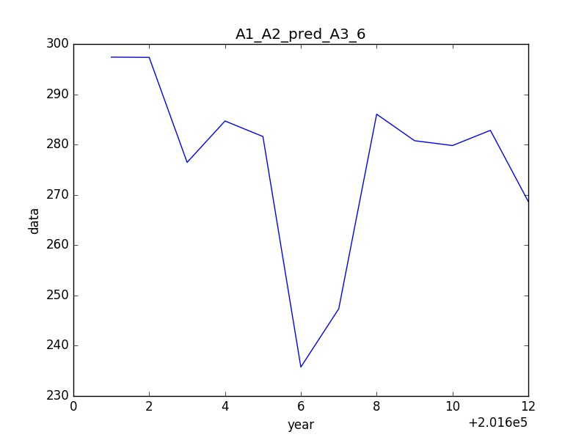

201601: 297.387040044

201602: 297.338653353

201603: 276.461195778

201604: 284.684699341

201605: 281.602107366

201606: 235.751433269

201607: 247.345597846

201608: 286.041379729

201609: 280.768582642

201610: 279.810136861

201611: 282.831156591

201612: 268.673794764

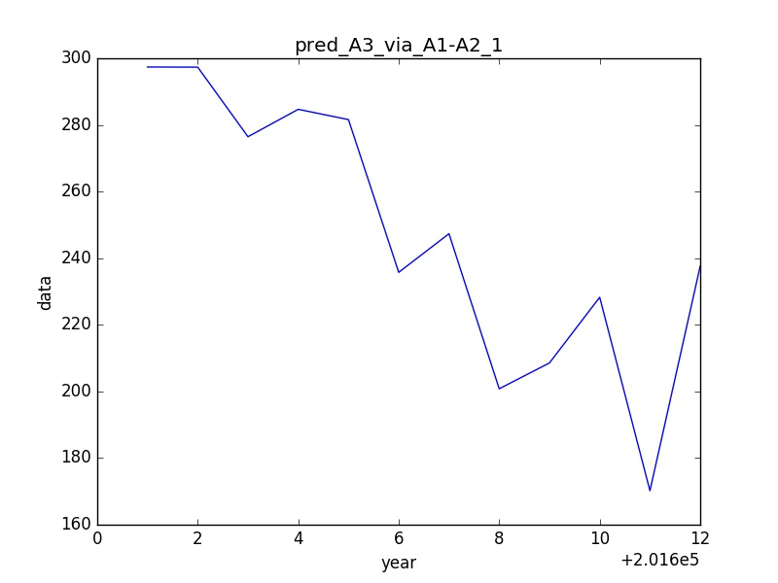

201601: 297.387040044

201602: 297.338653353

201603: 276.461195778

201604: 284.684699341

201605: 281.602107366

201606: 235.751433269

201607: 247.345597846

201608: 200.799996608

201609: 208.554664768

201610: 228.271940318

201611: 170.201637328

201612: 237.61189131

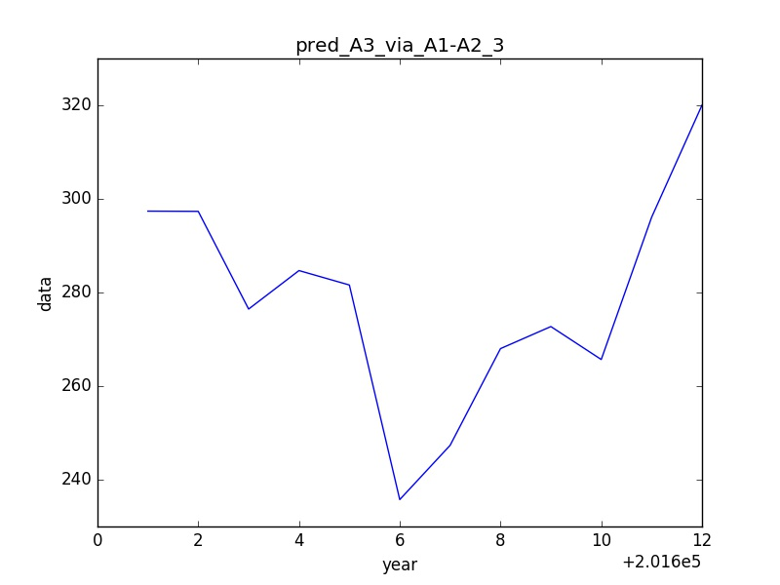

201601: 297.387040044

201602: 297.338653353

201603: 276.461195778

201604: 284.684699341

201605: 281.602107366

201606: 235.751433269

201607: 247.345597846

201608: 268.010471422

201609: 272.72287216

201610: 265.683550674

201611: 296.074132787

201612: 320.031637871

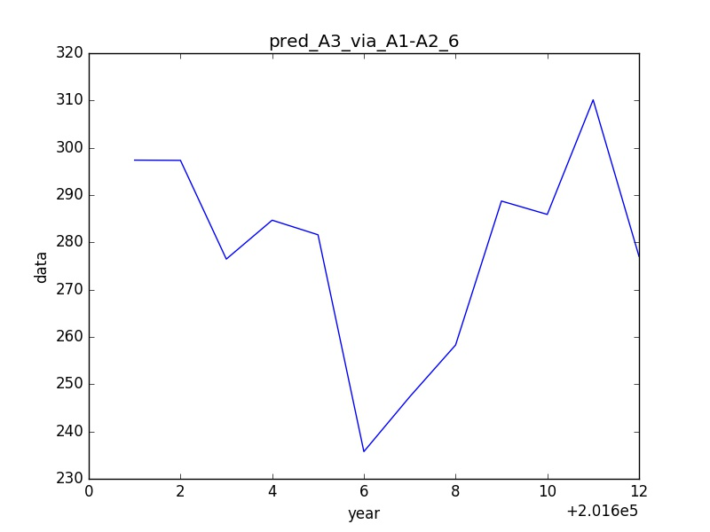

201601: 297.387040044

201602: 297.338653353

201603: 276.461195778

201604: 284.684699341

201605: 281.602107366

201606: 235.751433269

201607: 247.345597846

201608: 258.289898414

201609: 288.733939711

201610: 285.908031216

201611: 310.13925132

201612: 277.050953275